**4**



***Celebration of Geoff Hill’s Life*** The service of celebration of the life of **Geoff Hill** will be held in our church on **Friday, 13 December,**

**2.15 pm**. If you are planning to attend, please bring a plate to share for the afternoon tea.

**Vintage Coffee Group will meet on Wednesday 11 December 2.30pm, at Royal Aero Club, Jandakot.**

**This year’s Christmas Carols will be held on Sunday, 15 December, 6.00pm**. The night will be filled with carols singing, sausage sizzles, games, quiz, and fun! Please bring your own non–alcoholic drinks. If you would like to contribute a Christmas—themed performance during the night, please let Rev. Toby Keva know.

***Rev. Toby Keva's Weekly Diary:***

**Working from Church**: Monday, Wednesday, Thursday, Sunday

**Working from Home:** Friday **Days Off: Tuesday, Saturday**



***Prayerbook and Offering***

**Rosters: Sunday 8 December 15 December 2024**

**Minister:** Rev Toby Keva Rev Toby Keva

**Readers:** L Muir, J Rowson A Witherington, W Wilson

**Organist:** Barbara Bennewith Barbara Bennewith

**Stewards:** A Barter, J Burns, N Loudon R Rowson, J Maddocks, E Kenny

**Greeter:** Louise Riedel Gwen Stevens

**Welcomer:** Phyllis Muller Phyllis Muller

**Morning Tea:** Lois & John Murdock L Kenny, J Heath

**Audio Visual:** Eddie Riedel Judy Rowson

**Worship Elder:**  Diane Boon

**Steward Enquiries: Ed Kenny**: Phone 0439 558 036

**1**

**8 December 2024**

**Willetton Uniting Church**

**Presbytery of Western Australia**

<https://willetton.ucwa.au/>

Caprice Place (off Herald Avenue)

**Minister: Rev Toby Adhityas Keva Sunday Service 9.15am**

**Email:** [*toby.keva@me.com*](mailto:toby.keva@me.com)

**Office:**(08) 9527 1014**Mobile:**0411 831 695

**Chair of the Church Council:**

**Bruce Read**: Ph:08 94574609

**Mobile**: 0477 400 022

**Steward Enquiries:**

**Ed Kenny** Mobile: 0439 558 036

**Items for the newsletter send to Louise’s email:**louise.riedel@iinet.net.au

**Phone**:08 9458 7989

**Mobile:** 0422 814 230

**N E W S L E T T E R**

**Our Mission**

** To Participate in and Grow the Mission of God at Willetton by**:

•**Sharing the love of God and**

•**Telling people about Jesus**

* **Our Vision**

**God’s Love and Hope in Action**

# 2

**Bible Reading: Luke 3:1-14.**

John the Baptist was not a nice preacher. He called those who listened to him venomous snakes! He talked about God’s axe, ready to cut! No wonder that Luke’s Gospel uses the text from Isaiah about straightening out crooked roads and ironing out rough places as the background for John’s ministry. John indeed continued Isaiah’s message about God’s demand that every ‘crooked’ and ‘rough’ places in people’s lives be straightened before God’s arrival. Unlike John, however, we often avoid talking about God’s judgement nowadays. But at the heart of God’s judgement is not punishment, but accountability. We are to be accountable, before God, for the way we live. Have we shared what we have with others? Have we looked after the vulnerable? Have we cared for God’s creation? Have we treated others the way we would like to be treated? Have we opened our eyes to the injustices before our eyes? Advent is about preparing ourselves for the arrival of God who demands righteous living **(Rev. Toby Keva)**

**Bible Reading Today, 8 December 2024**

Malachi 3:1-4, Luke 1:68-79

Philippians 1:3-11, Luke 3:1-6

**Bible Reading Sunday 15 December 2024**

Zephaniah 3:14-20, Isaiah 12:2-6

Philippians 4:4-7, Luke 3:7-18

**Prayer for the week from 8 December**

Dongara Uniting Church Frontier Services WA Bush Chaplains and Methodist Church of Sri Lanka

.

**UC Willetton** to all members who receive the Newsletter by email you

also can download the Newsletter from the church’s website. The link is

<https://willetton.ucwa.au/home/newsletters/>

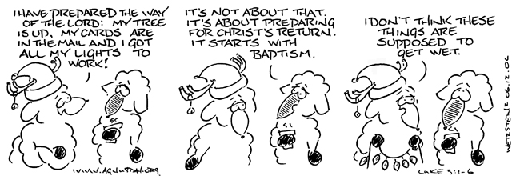

**3**

**“**[**Peace In The Prince Of Peace"**](https://www.sermoncentral.com/sermons/advent-week-2-peace-quot-peace-in-the-prince-of-peace-quot-dean-courtier-sermon-on-advent-277268)



**As our Advent journey unfolds, our hearts are drawn to the theme of peace. Today, we explore the promise of a coming Messiah, a Prince of Peace, as foretold by the prophet Isaiah**.

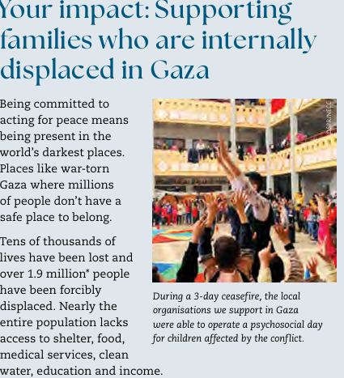

Your support can help our local partner continue to provide lifesaving medical care to help respond to this unprecedented humanitarian crisis.